**Turn the page**

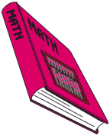

A novel has 527 pages (pages 1 – 527).  How many digits will it take to number all 527 pages from 1 to 527?